Case Diagram - Government and Independences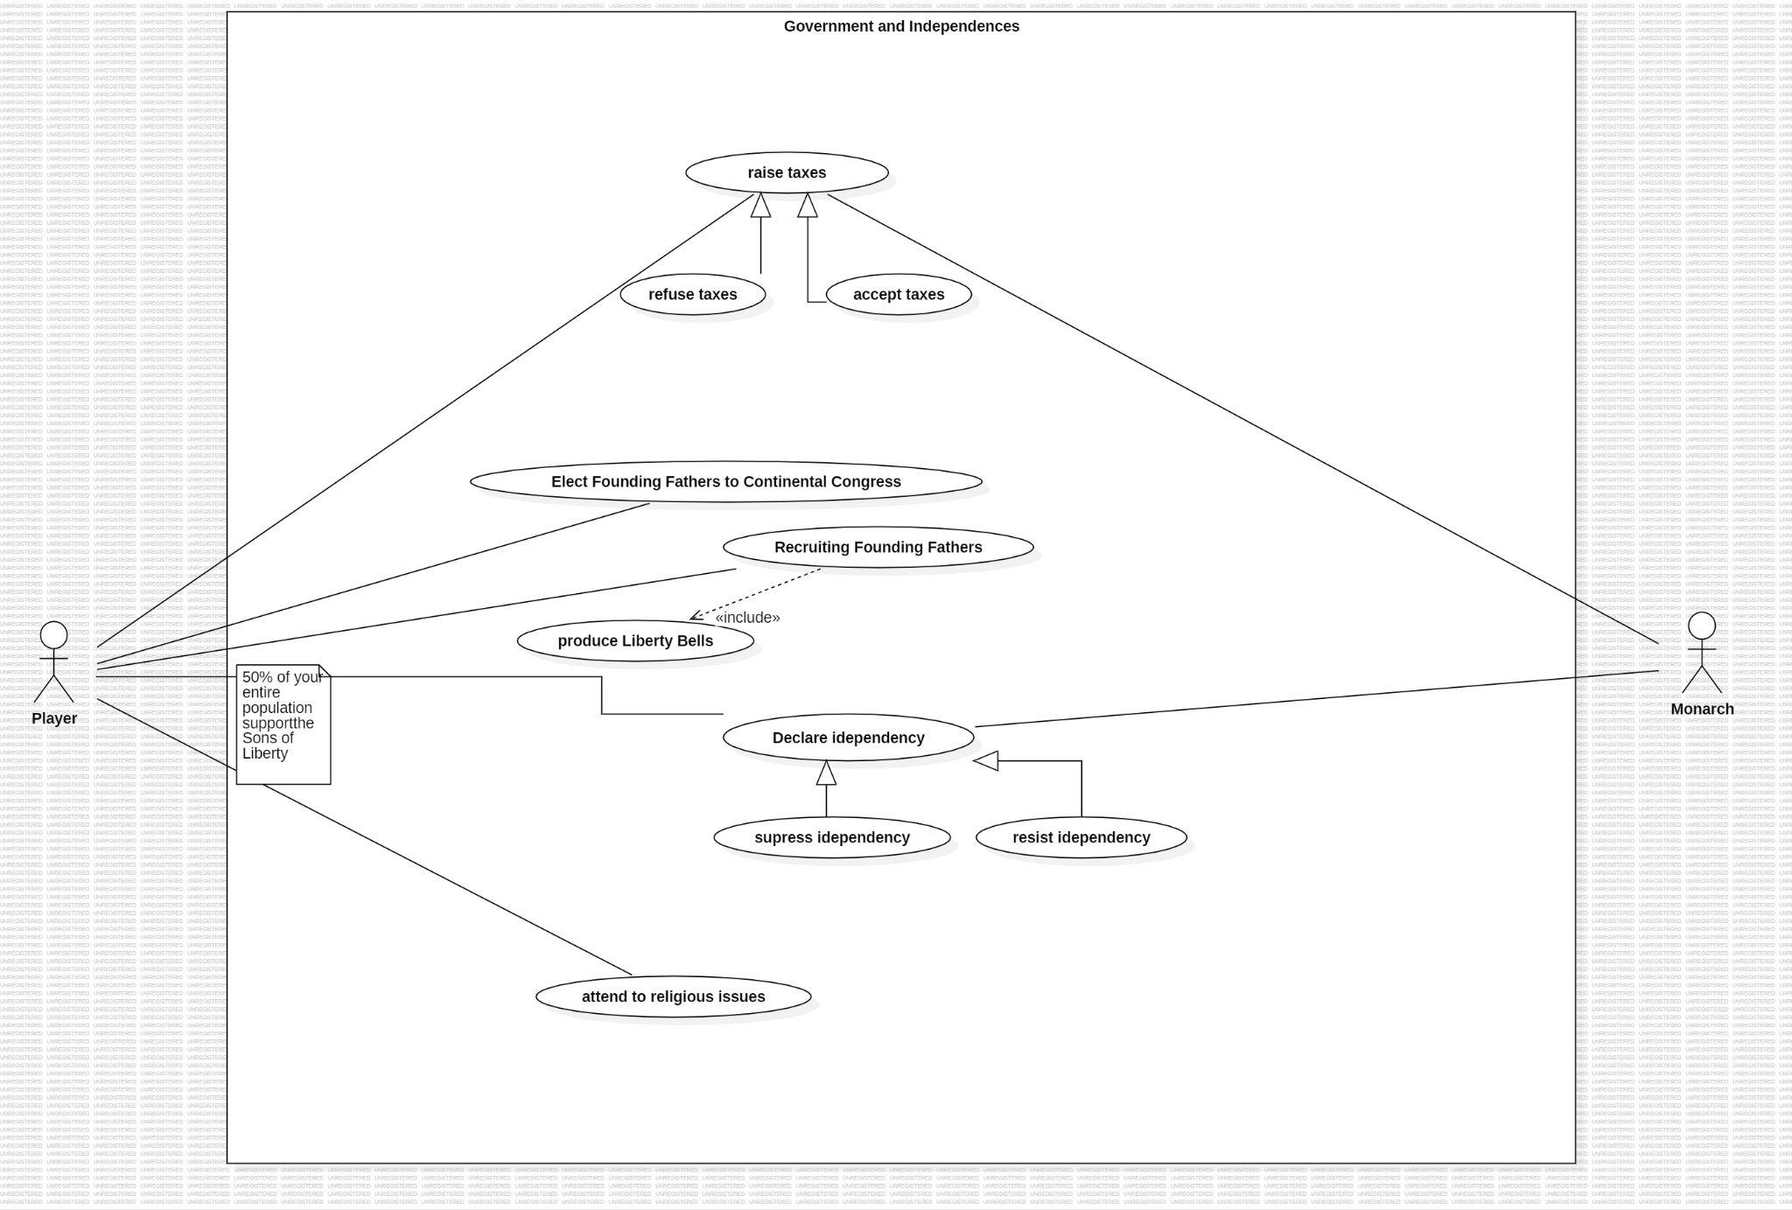

TODO: consertar idepency -> idependence

The main actor in this use case diagram is the “Player”, i.e., the human Player who is playing the game. We also have a Secondary actor, Monarch, that is an AI.

The main actor can interact with this context by:

1. **Refusing and Accepting the taxes** that are imposed by the Monarch.
2. **Elect Founding Fathers to Continental Congress,** they will represent you and give benefits for your nation.
3. **Declare Independence,** opposing the Monarch, and being free to not pay the taxes but initiating a conflict.
4. **Attending religious Issues** may let your colony members be satisfied with your administration.It could be a good idea if the player want to maintain the peace in your territory.